**Installation Guide for R and RStudio**

Step 1 – Install R

1. Download the R installer from <https://cran.r-project.org/>

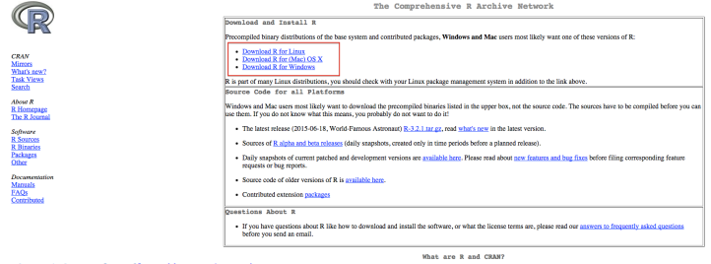

Image 1. Screenshot of <http://cran.csiro.au/>

1. Run the installer. Default settings are fine.

Step 2 – Install RStudio

1. Download RStudio: <https://www.rstudio.com/products/rstudio/download/>

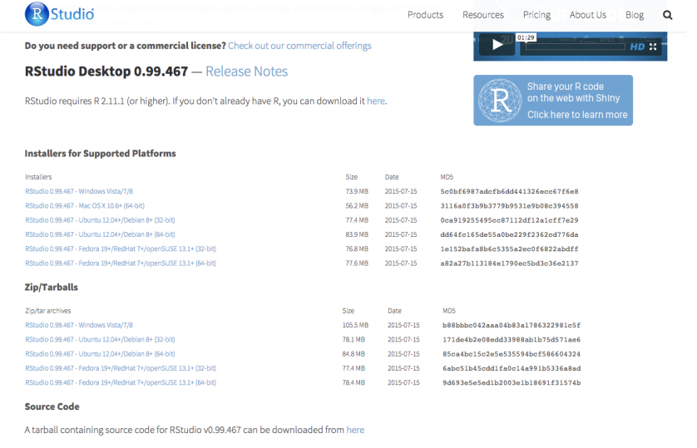

Image 2. Screenshot of <https://www.rstudio.com/products/rstudio/download/>

1. Once the installation of R has completed successfully (and not before), run the RStudio installer.

Step 3 – Check that R and RStudio are working

1. Open RStudio. It should open a window that looks similar to image 3 below.
2. In the left hand window, by the ‘>’sign, type ‘4+5’(without the quotes) and hit enter. An output line reading ‘[1] 9’ should appear. This means that R and RStudio are working.
3. If this is not successful, contact us for further advice.

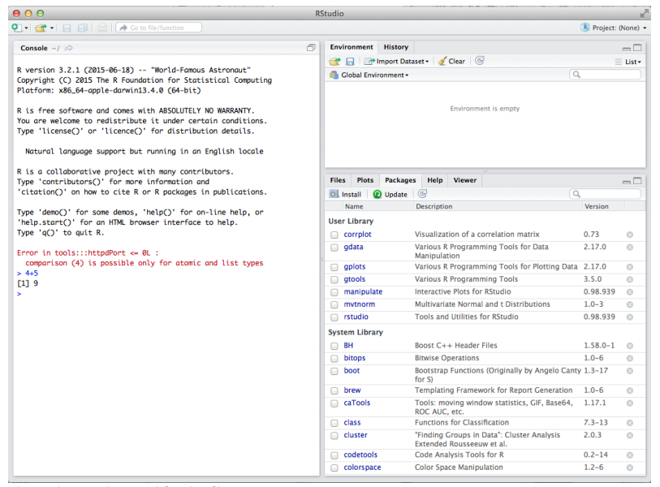

Image 3. Running R with RStudio

Step 4 – Install R packages required for the workshop

1. Click on the tab ‘Packages’ then ‘Install’ as shown in Image 4. Or Tools -> Install packages.
2. Install the following packages: ggplot2, rpart, rpart.plot, rattle, FSelector, caret, gmodels, ROCR

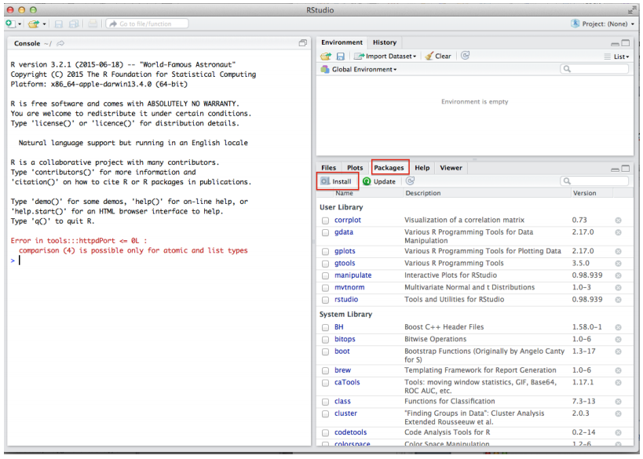

Image 4. Click on Install to install R packages.

1. Check that the packages are installed by typing ‘library(ggplot2)’ (without the quotes) in the prompt and press enter. Repeat for all other packages: rpart, rpart.plot, rattle, FSelector, caret, gmodels, and ROCR.

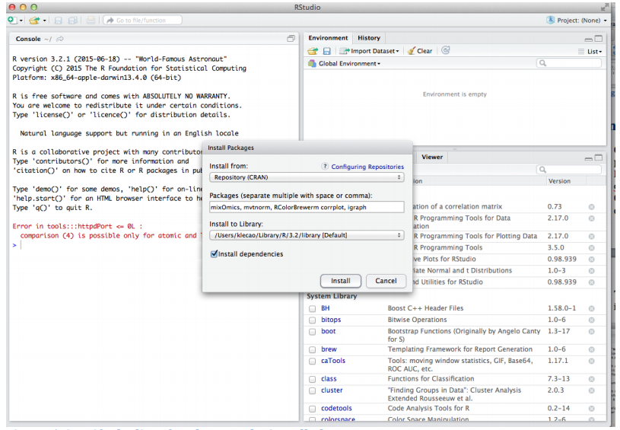

Figure 5. Specify the list of packages to be installed

1. Then type ‘sessionInfo()’ and check that ggplot2 and all other packages have been installed

That’s it! Can’t wait to get started!